**CS2023 - Data Structures and Algorithms**

**In-class Lab Exercise**

Week 6

**You are required to answer the below questions and submit a PDF to the submission link provided under this week lab section before end of the session time (no extensions will be provided). You can either write / type your answers, but either way your answers should be readable.**

Create GitHub repository, add your codes there and add respective link to the submission file.

**Exercise:**

***Stack*** is a linear data structure which is a collection of elements which are inserted or deleted according to the LIFO rule i.e. Last-In-First-Out. Take the example of a stack of disks which are placed one on top of another we keep on adding new disks to the top and when we need to take one, we take the topmost one very similar to how a stack works.

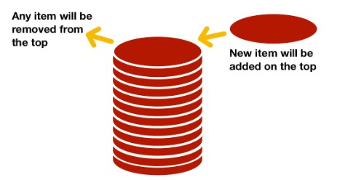

**Operations performed with a Stack**:

* Push() - To insert data into the stack
* Pop() - To remove/delete data from the stack
* isEmpty() - To check whethet a stack is empty or not
* isFull() - To check whethet a stack is full or not
* StackTop() - To find what is at the top of the stack
* Display() – To print elements in the stack

1. Implement Stack and its functions using **Array.** Consider the given example pseudo code for push and pop using array.

Watch the following video for more details:

<https://www.youtube.com/watch?v=rS-ZKTqwi90&ab_channel=NesoAcademy>

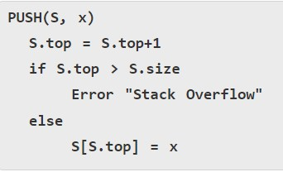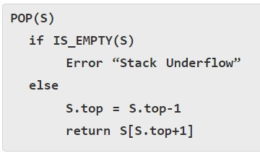

1. Implement Stack and its functions using **LinkedList**. Consider the given example pseudo code for push and pop using linked list.

Watch the following video for more details:

<https://www.youtube.com/watch?v=0-kkDfCOXOI&ab_channel=NesoAcademy>

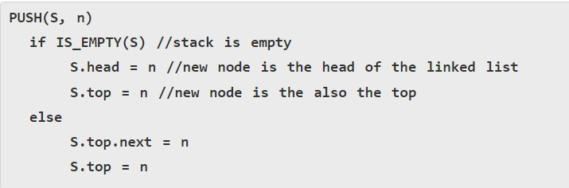

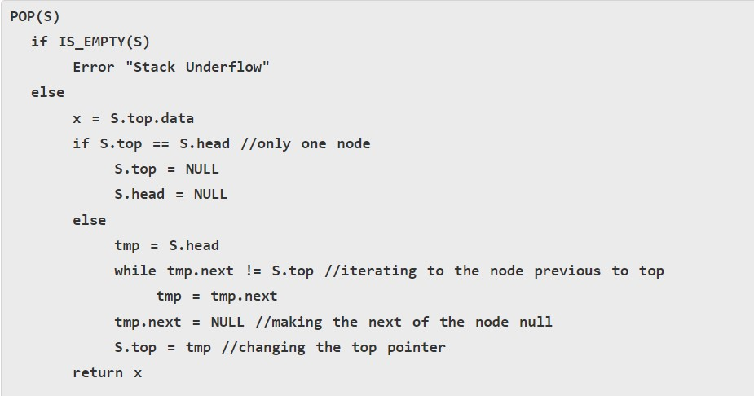

1. Execute the following operations if Stack. Compare the time taken for execution between your implementation using array and LinkedList. (Note: you can randomize the value for push operation)

Push(8)

Push(10)

Push(5)

Push(11)

Push(15)

Push(23)

Push(6)

Push(18)

Push(20)

Push(17)

Display()

Pop() × 5 times

Display()

Push(4)

Push(30)

Push(3)

Push(1)

Display()

**Results:**

|  |  |  |
| --- | --- | --- |
| Test No. | Array Approach Time | Linked List Approach Time |
| 1 | 3825900 | 1684300 |
| 2 | 4930500 | 1696400 |
| 3 | 4889000 | 1743600 |
| 4 | 4526200 | 1575500 |
| 5 | 4758700 | 1749600 |
| average | 4580060 | 1695880 |

Comparison: Array implementation have taken more time compared to linked list implementation. But linked list implementation takes more space in memory.

**Git repo link : https://github.com/Hansa2000/CS2023-labs**